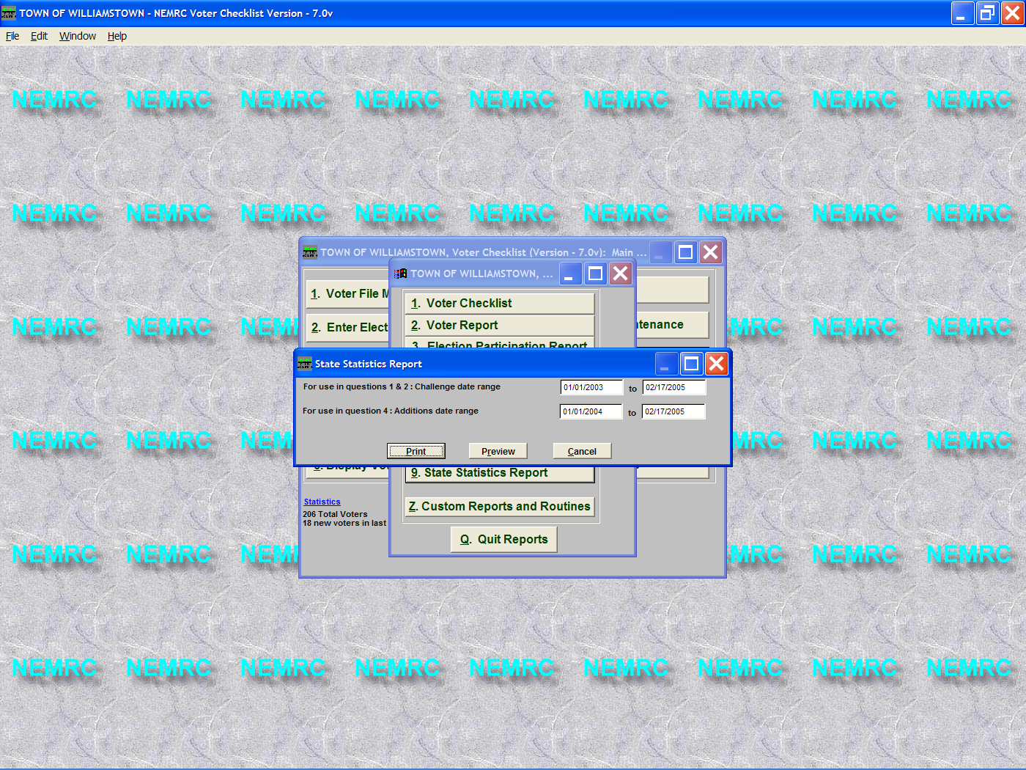

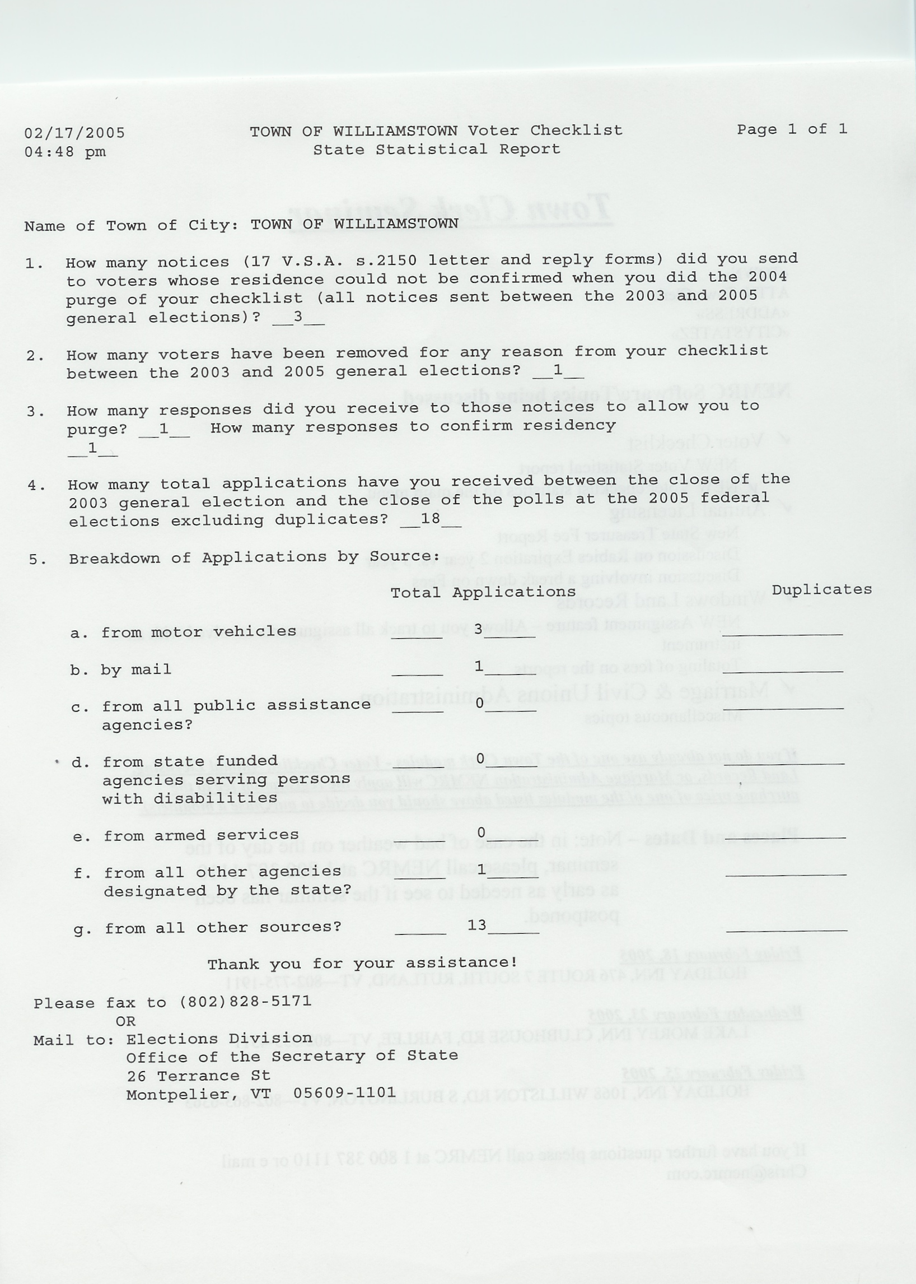
1.Relates to the ‘Chall Lttr Date’ on the Voter Maint Screen.
2. Looks at date moved to history.
3. 1st part of this question. The ‘Challenge’ field must be ‘Y’, ‘Chall Lttr Date; must be within date range entered on above screen and the ‘Lttr Recvd’ must have a valid date.
2nd part only looks for a date in the ‘Lttr Recvd’ field.

4. Simply the # of applications you entered where the ‘Application date’ is between the dates you entered on the previous screen.

5. This relates to the ‘Source’ in which the person applied with. This only includes people that applied between the dates entered on the previous screen seen above.

